**Case Study Title: Muzzle Movement Job Location Tracking**

**Business Overview (*Max 50 words*)**

The Muzzle Movement are a UK-based SME who make muzzles for dogs of all breeds. The muzzles are designed with ethical considerations in mind, to ensure the dogs can pant properly, drink easily and are generally comfortable whilst making them less scary. The muzzles come in various colours and strap designs, with new variants regularly being introduced based on demand. As a result, there are around 180 variants of the product at the time of this project.

**Situation (*Max 220 words*)**

The company approached SMDH to assist them in their digital journey and enable them gain insights into their production process by identifying bottleneck areas. They also wanted a tool that could help them keep track of production of the various products such that they can anticipate demands whilst adjusting their inventory accordingly. SMDH installed RFID scanners in the company so that they can capture data between different areas during the production of the muzzles and livestream these onto the MDEP. The data being captured was used to create the analytics which was displayed on an interactive dashboard and shared with them, with consideration given to the most value-adding analyses for the company. This is a summary of the project with explanation of some of the analyses.

**Solution (*Max 220 words*)**

The data contain timestamps for the different locations that the company is monitoring. In the exact order of the locations, these include Complete, Punched, Waiting, Local Painting, Drying and Stored. With flexibility given to the company in modifying the RFID system, the Complete and Stored locations were designated as the start and end of the process. The activities in the other locations are literally as described. The company also identified the Waiting and Drying locations to involve non-human work hours, and they want an exclusion of these two locations in the analyses.

The ETL data pipeline involve raw data flowing from the bronze to silver lake on S3 and the storage of relevant files in the silver lake, which were then exported into QuickSight. The streaming data was first accumulated from the bronze to silver lake using a Glue script. Another script was then written to analyse the accumulated data and output relevant files, which were related to the requirements of the company. Particularly, data relating to how long it took to make different products and the proportion of time which products spend in different locations were outputted and stored in the silver lake. The final dashboard was created to include functionalities which make it easy for the company to filter by dates, select certain products and breakdown the analyses based on the different variants they are making.

The main challenge faced in this project is regarding the introduction of human error during data collection, which affects the overall quality of the data. There were instances where the company forget to scan certain locations or states during production. There were also instances where data was duplicated. The scripts have been written, baring these in mind, to try and mitigate these potential error sources as best as possible. For example, when the “entered” state of a certain location was not recorded, the “exited” state of a previous location was used as a proxy. Similarly, when the “exited” state was not recorded, the “entered” state of the next location was used. In addition, duplicated information were simply addressed to retain one unique data point.

**Explanation of results**

A high-level summary of the data was first presented in a separate tab as an indicator of how well the company are scanning and capturing information about the different locations.

The top-left plot shows the proportion of times the “entered” and “exited” are recorded per location. Ideally, this should 50-50 since every product entry into a location must have an exit state. The plot shows that, for example, the “entered” state of the Stored location was being recorded 75% of the time compared to 25% for the “exited” state. The company can then pay extra attention to the “exited” state of the Stored location and make sure they remember to scan this state.

The top-right plot gives a quick summary of the frequency of scans per product across different locations and states, as an indication of which product is the best monitored in terms of the number of scans. In the plot, this is Buckle Black; however, this does not necessarily mean Buckle Black is the most frequently made product.

The bottom-left plot is the number of scans which the company has made per location, regardless of the state and based on the available data. This clearly shows the Stored location is the most scanned, thus indicating the company remembers to scan the end of the process more than when the product is transiting through different locations. Although, a lot of the scan contributions are via the “entered” state.

The bottom-right plot shows the frequency of the recorded states namely “entered” and “exited” although there was a “changed” state which the company temporarily introduced but have since discontinued. The plot supports the top-left plot and confirms that both states are indeed not even recorded. The “entered” state was recorded ~ 64% more than the “exited” was captured. This intuitively means that the company remembers to capture information about the “exited” state more than they are doing the “entered”.

Because not all products have the same location, a one-to-one mapping of the products and their locations are plotted in a heat map which shows the number of occurrences of certain locations.

This can give an indication of anomalies, where products which should not have certain locations have these incorrectly recorded. For example, black-coloured products should not have Local Painting and Drying. If these were recorded for a particular black product, this would be incorrect and the company can clearly see this, and make sure they are avoiding such errors going forward.

All of these were aimed at ensuring the company can improve the quality of the data being captured at source, which would then enhance the veracity and reliability of the analytics.

A different tab also shows the quantity of products made and the length of material used to make them. The dashboard allows the company to see this information immediately and enable them to know which products they have produced the most between selected time periods and over the entire data, since they started gathering data. This analysis was also made on a more granular weekly basis, so that the number of products made can be monitored per week.

The company also wanted to see how many quantities of the different products they are making and use this as an indication of the demands from customers. This would also enable them to adjust their inventory levels and properly plan for production. A weekly and monthly analyses of the quantity made and the length of material required was created per product. The company can choose an individual product and see the trend in quantity and material length required over a period and use that as an indication of demand. For example, for Buckle Black, there has been a monthly downward trend in the quantity made. Thus, this can signify there has been a reduction in the demand of Buckle Black. The company can decide to investigate reasons for this dip in demand or be less optimistic about future demands and adjust inventory accordingly.

Another tab analysed the average duration it took to make the products alongside the proportion of time products were spending in different locations. The plots below summarise these analyses and show, for example, that Sunny Strap Peach was taking the longest time to make on average (~6.6 hrs) over the entire period that data was available. However, between 1st July and 30th September 2024, Tolly Nose Violet was taking the longest to make, with an average time of ~ 6.1 hrs. In addition, the company can see a daily breakdown of how long it was taking to make a certain product, that they choose from the list of all available products, on the days that product was made.

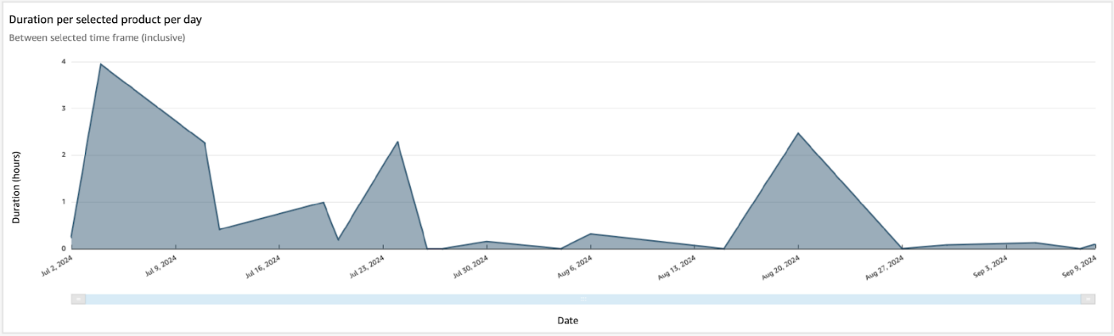

In addition, the proportion of time products are spending at different locations were also analysed and shown in the plot below. This would give an indication of which location was taking the most time for each product. A breakdown of this for a particular product can allow the company to explore certain locations which could potentially serve as bottlenecks in the production process.

A breakdown of the above analyses was also made by colour and strap variants, which will enable the company to see the details of the products clearer and make like-for-like comparison e.g., compare all black or buckle straps. A separate analysis was also made to exclude Waiting and Drying locations, which were non-human related.

**Successes (*Max 200 words*)**

The Muzzle Movement has provided live, streaming data to SMDH through the MDEP. The raw data has been transformed and analysed to address some of the most important questions and requirements which the company has about their production process. Particularly, the ability to get an estimate of the time it takes to make their products to know which ones are taking the longest to make or which are the quickest. The ability to also track individual locations will also aid in addressing potential bottleneck areas during production. In addition, the company wanted SMDH to develop the analytics that will allow them keep track of production quantities and the length of raw materials required to make individual products. This will enable the company to anticipate future demands and adjust planning for their inventories. SMDH has provided a detailed analyses that answer these questions and captured these requirements as best as possible. A user-friendly, functional and interactive dashboard, which showcases the results from these analyses, has been provided to the company with explanation and guidance on how use it effectively. This project serves as the first job tracking related analyses, and the data architecture and analytics implemented here will be developed into a more reusable asset to enable future job tracking projects to be quickly analysed.

